PP_2018_LPOOL_001_03(IRF20/3759)

Dr Eddie Jackson
Acting Chief Executive Officer
Liverpool City Council
Locked Bag 7064
Liverpool BC NSW 1871

Dear Dr Jackson

Planning proposal PP_2018_LPOOL_001_03 – Alteration of Gateway Determination

I refer to Council’s request seeking an extension of time to complete planning proposal PP_2018_LPOOL_001_03 to allow signage as a permissible use with consent in the B3 Commercial Core and B4 Mixed Use zones within the Liverpool City Centre.

I have determined as the delegate of the Minister, in accordance with section 3.34(7) of the Environmental Planning and Assessment Act 1979, to alter the Gateway determination dated 23 January 2018 for PP_2018_LPOOL_001_00 (since altered). The Alteration of Gateway determination is enclosed.

If you have any questions in relation to this matter, I have arranged for Ms Cho Cho Myint to assist you. Ms Myint can be contacted on 9860 1507.

Yours sincerely

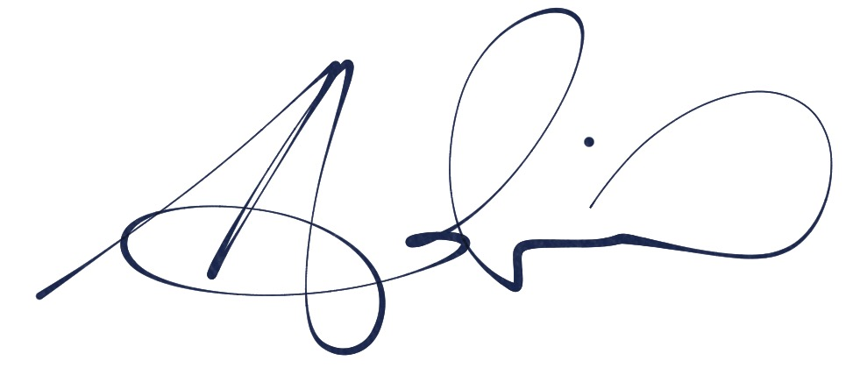11 Aug 2020
Adrian Hohenzollern
Director Western
Central River City and Western Parkland City

Encl: Alteration of Gateway Determination

